**Track Purchase Request**

* **Actor**
* **Admin**
* **Approver**
* **Requestor**

**Use Case Description:**

* The user wants to view the details of a specific request to gain more insight into its status and contents.

**Trigger**

* The user clicks on a specific request in the table on the request screen.

**Pre-Condition:**

* The user is authenticated and authorized to view the request details.

**Post Condition:**

* The user can view all the information related to the request, including its status, items, attachments, comments, supplier information, and activity logs.

**Normal Flow**

* The user clicks on a specific request in the table on the request screen.
* The system opens the request details page.
* The user sees the Request No, tags related to that request, and tabs for request overview, attachments, comments, supplier info, and activity logs.
* The user clicks on the request overview tab.
* The system displays the request details, including Requestor name, Location, Delivery Date, Creation Date, request type, department, Item, Final Approver, and total request amount.

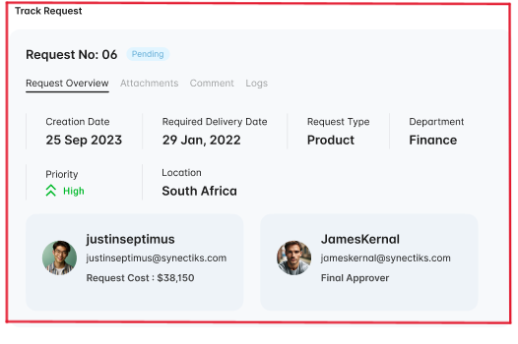

* The system displays the Order line item table with the fields Name, Category, supplier, quantity, unit, price, and total cost.

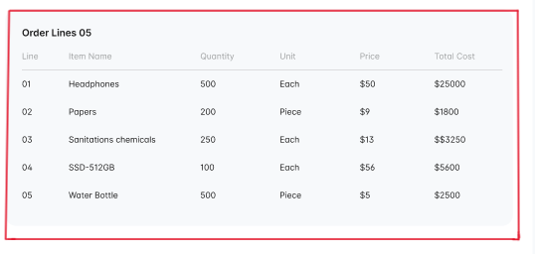

* The user clicks on the attachments tab.
* The system displays all the attachments related to the request in a table with fields like File name, file size, date uploaded, and Uploaded by.

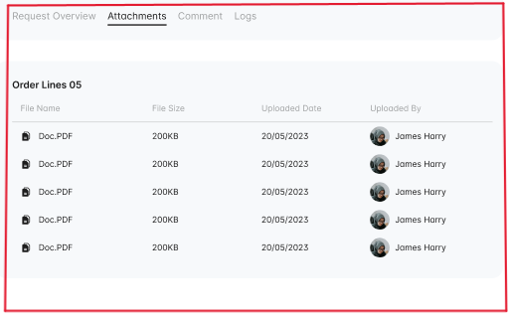

* The user clicks on the comments tab.
* The system displays all the comments related to the request.

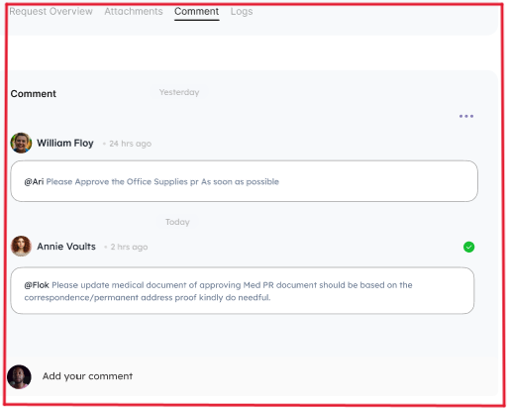

* The user clicks on the supplier info tab.
* The system displays the information of the supplier, including Supplier name, Supplier email, Supplier contact, business category, telephone No, and Mailing address.
* The user clicks on the activity logs tab.
* The system displays all the user activities related to the request in a table with fields like User, action, type, and timestamp.

**Alternative Flow**

* If the user wants to view the attachments related to the request, they can skip step 5 and go directly to step 7.
* If the user wants to view the comments related to the request, they can skip step 5 and go directly to step 9.
* If the user wants to view the supplier information related to the request, they can skip step 5 and go directly to step 11.
* If the user wants to view the activity logs related to the request, they can skip step 5 and go directly to step 13.